Table of Contents

THEORETICAL ANALYSIS 2

Basic operation is the comparison marked as (1) 2

Basic operations are the three assignments marked as (2) 2

Basic operation is two assignments marked as (3) 3

Basic operations are the two loop incrementations marked as (4) 4

Basic operation is the assignment marked as (5) 4

IDENTIFICATION OF BASIC OPERATION(S) 5

REAL EXECUTION 5

Best Case 5

Worst Case 5

Average Case 5

COMPARISON 6

Best Case 6

Worst Case 8

Average Case 10

## THEORETICAL ANALYSIS

### Basic operation is the comparison marked as (1)

Independent of the input we always perform the operation $n$ times. There is no distinction between best, worst and average cases.

Hence,

$$B\left(n\right)= W\left(n\right)= A\left(n\right)= n ∈θ\left(n\right)$$

#### Analyze B(n)

As stated above,

$$B(n) = n ∈θ(n)$$

#### Analyze W(n)

As stated above,

$$W(n) = n ∈θ(n)$$

#### Analyze A(n)

As stated above,

$$A(n) = n ∈θ(n)$$

### Basic operations are the three assignments marked as (2)

Consider the number of times the basic operation is performed provided that condition $m$ is true is $τ_{m}$.

If the first condition is true $(arr[i]==0)$ then the for loop executes $(n-i)$ times and the while loop will execute $k$ times, which is $logn$. Therefore, in total there will be $(n-i)*logn$ number of executions of the basic operation.

$$τ_{1}=\left(n-i\right)*logn$$

If the second condition is true $\left(arr\left[i\right]==1\right)$ then both the outer and the inner for loops execute $n$ times and the while loop will execute times as discussed above. Hence,

Outer for loop executes n times. Inner for loop will execute times and values of ranges from to . So the total number of operations will be

#### Analyze B(n)

Since is the smallest, best case occurs when the first condition is always true.

$$B\left(n\right)= \sum_{i=0}^{n-1}{τ_{1}}= \sum_{i=0}^{n-1}{\left(n-i\right)logn} = logn\sum_{j=1}^{n}{j}=logn*\frac{n\left(n+1\right)}{2}$$

$$B\left(n\right) ∈θ(n^{2}logn)$$

#### Analyze W(n)

Since $τ_{3}$ is the greatest, worst case occurs when the third condition is always true.

$$W\left(n\right)= \sum_{i=0}^{n-1}{τ_{3}}= \sum_{i=0}^{n-1}{\frac{n(n+1)(2n+1)}{6}} =n *\frac{n(n+1)(2n+1)}{6}$$

$$W\left(n\right) ∈θ(n^{4})$$

#### Analyze A(n)

The probability of each of the conditions to be true is $\frac{1}{3}.$

$$A\left(n\right)= \sum_{i=0}^{n-1}{\frac{1}{3}τ_{1}}+ \frac{1}{3}τ_{2}+ \frac{1}{3}τ_{3}= \frac{1}{3}\sum_{i=0}^{n-1}{\left(n-i\right)*logn+ \left(n^{2}\right)*logn+ } \frac{n\left(n+1\right)\left(2n+1\right)}{6}= \frac{1}{3}\left(logn*\frac{n\left(n+1\right)}{2}+ \left(n^{3}\right)*logn+ \frac{n^{2}\left(n+1\right)\left(2n+1\right)}{6}\right)$$

$$A\left(n\right) ∈θ(n^{4})$$

### Basic operation is two assignments marked as (3)

We will make our analysis similar to the second part.

If the first condition is true $(arr[i]==0)$ there will be no basic operation execution.

$$τ_{1}=0$$

If the second condition is true $\left(arr\left[i\right]==1\right)$ then both the outer and the inner for loops execute $n$ times and the while loop will execute times as discussed above. Hence,

Outer for loop executes n times. Inner for loop will execute times and values of ranges from to . So the total number of operations will be

#### Analyze B(n)

Since is the smallest, best case occurs when the first condition is always true.

$$B\left(n\right)= 0$$

$$B\left(n\right) ∈θ(1)$$

#### Analyze W(n)

Since $τ_{3}$ is the greatest, worst case occurs when the third condition is always true.

$$W\left(n\right)= \sum_{i=0}^{n-1}{τ_{3}}= \sum_{i=0}^{n-1}{\frac{n(n+1)(2n+1)}{6}} =n *\frac{n(n+1)(2n+1)}{6}$$

$$W\left(n\right) ∈θ(n^{4})$$

#### Analyze A(n)

$$A\left(n\right)= \sum_{i=0}^{n-1}{\frac{1}{3}τ_{1}}+ \frac{1}{3}τ_{2}+ \frac{1}{3}τ_{3}= \frac{1}{3}\sum_{i=0}^{n-1}{0 + \left(n^{2}\right)*logn+ } \frac{n\left(n+1\right)\left(2n+1\right)}{6}= \frac{1}{3}\left(0+ \left(n^{3}\right)*logn+ \frac{n^{2}\left(n+1\right)\left(2n+1\right)}{6}\right)$$

$$A\left(n\right) ∈θ(n^{4})$$

### Basic operations are the two loop incrementations marked as (4)

The basic operations are the 2 loop incrementations. Again the most outer for loop executes n times.

If the second condition is true $(arr[i] == 1)$, the following loop $(for t2 ← n downto 1 do)$ executes n times. For each iteration of this loop our basic operation of loop incrementation of $p2$ occurs $n$ times. Hence, there will exactly be $n^{2}$ operations.

If the third condition is true $(arr[i] == 2)$, the loop incrementation of $t3$ will

occur $n$ times.

#### Analyze B(n)

The best case occurs when the first condition is always true, which means the basic operations never execute. Hence,

$$B\left(n\right)= 0$$

$$B\left(n\right)∈θ(1)$$

#### Analyze W(n)

It is observed that the worst case happens when the second condition is always true.

$$W\left(n\right)= \sum_{i=0}^{n-1}{n^{2}}= n^{3}$$

$$W\left(n\right) ∈θ(n^{3})$$

#### Analyze A(n)

The probability of each of the conditions to be true is $\frac{1}{3}$.

$A\left(n\right)= \sum_{i=0}^{n-1}{\frac{1}{3}*0}+ \frac{1}{3}*n^{2}+ \frac{1}{3}*n$ = $\frac{1}{3}*n*\left(n^{2}+ n\right)=\frac{1}{3}\left(n^{3}+ n^{2}\right)$

$$A\left(n\right) ∈θ(n^{3})$$

### 

### Basic operation is the assignment marked as (5)

Assignment marked as 5 occurs only when the first condition is true $(arr[i] == 0)$.

#### Analyze B(n)

Best case occurs when the first condition is not true and therefore no operation occurs.

$$B\left(n\right)= 0$$

$$B\left(n\right)∈θ(1)$$

#### Analyze W(n)

Worst case is when the first condition is true. In that case, there will be $\sum_{i=0}^{n-1}{n-i}$ operations. Since the outer for loop executes $n$ times.

$$W\left(n\right)=\sum_{i=0}^{n-1}{\left(n-i\right)} =\sum_{j=1}^{n}{j}=\frac{n\left(n+1\right)}{2}$$

$$W\left(n\right) ∈θ(n^{2})$$

#### Analyze A(n)

The probability of each of the conditions to be true is $\frac{1}{3}.$

$A\left(n\right)= \sum_{i=0}^{n-1}{\frac{1}{3}*\left(n-i\right)}+ \frac{1}{3}*0+ \frac{1}{3}*0$ = $\frac{1}{3}*\frac{n\left(n+1\right)}{2}$

$$A\left(n\right) ∈θ(n^{2})$$

## IDENTIFICATION OF BASIC OPERATION(S)

*Here, state clearly which operation(s) in the algorithm must be the basic operation(s). Also, you should provide a simple explanation about why you have decided on the basic operation you choose. (1-3 sentences)*

## REAL EXECUTION

### Best Case

|  |  |
| --- | --- |
| N Size | Time Elapsed |
| 1 | 0.000002 |
| 5 | 0.000006 |
| 10 | 0.000017 |
| 25 | 0.000115 |
| 50 | 0.000499 |
| 75 | 0.001352 |
| 100 | 0.002266 |
| 150 | 0.005961 |
| 200 | 0.009837 |
| 250 | 0.015278 |

### Worst Case

|  |  |
| --- | --- |
| N Size | Time Elapsed |
| 1 | 0.000002 |
| 5 | 0.000019 |
| 10 | 0.000189 |
| 25 | 0.006147 |
| 50 | 0.091153 |
| 75 | 0.456626 |
| 100 | 1.427150 |
| 150 | 7.298703 |
| 200 | 22.792678 |
| 250 | 56.791562 |

### Average Case

|  |  |
| --- | --- |
| N Size | Time Elapsed |
| 1 | 0.000003 |
| 5 | 0.000034 |
| 10 | 0.000285 |
| 25 | 0.004577 |
| 50 | 0.031439 |
| 75 | 0.145757 |
| 100 | 0.456666 |
| 150 | 2.194115 |
| 200 | 6.461470 |
| 250 | 14.111794 |

## COMPARISON

### Best Case

#### ImageGraph of the real execution time of the algorithm

#### ImageGraph of the theoretical analysis when basic operation is the operation marked as (1)

#### Graph of the theoretical analysis when basic operation is the operation marked as (2)

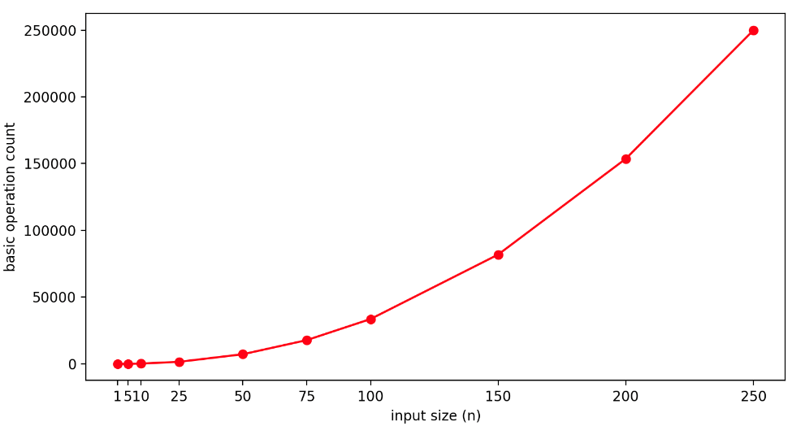

#### Graph of the theoretical analysis when basic operation is the operation marked as (3)

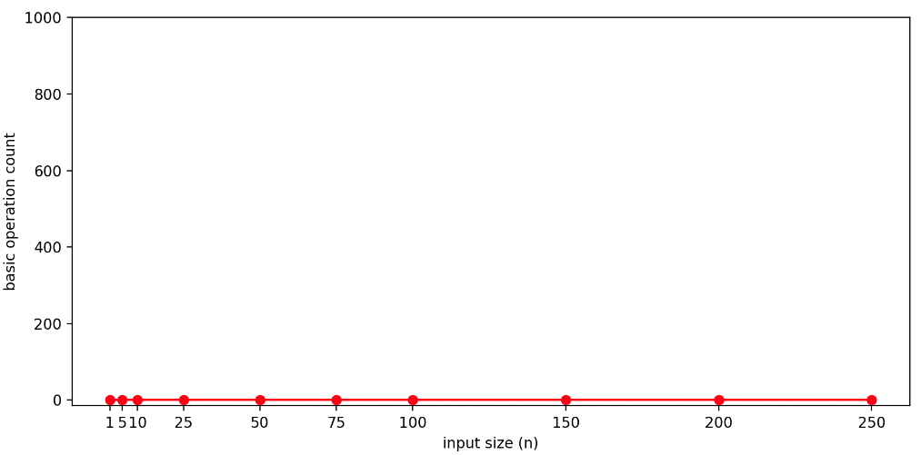

#### Graph of the theoretical analysis when basic operation is the operation marked as (4)

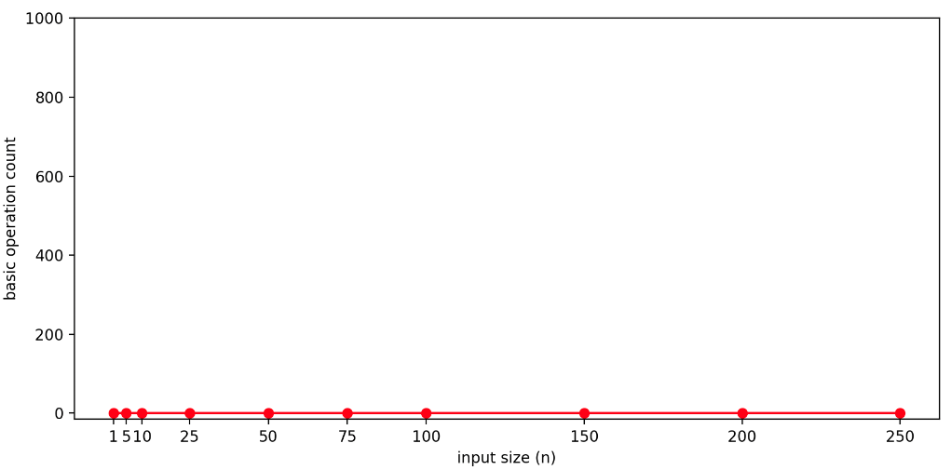

#### Graph of the theoretical analysis when basic operation is the operation marked as (5)

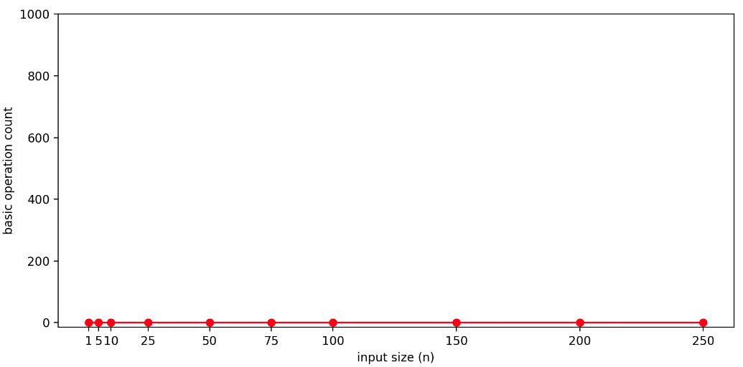

#### Comments

The graphs when basic operation is the operation (3), (4) and (5) are all constant and 0 since there isn’t any execution of the basic operation. When the basic operation is (1), the graph is linear. The growth rate that is the most similar to the growth rate of the real execution time graph is observed in the graph where the basic operation is operation (2) with growth rate $n^{2}logn$. This similarity supports our claim that the real basic operation of the algorithm is operation (2).

### Worst Case

#### Graph of the real execution time of the algorithm

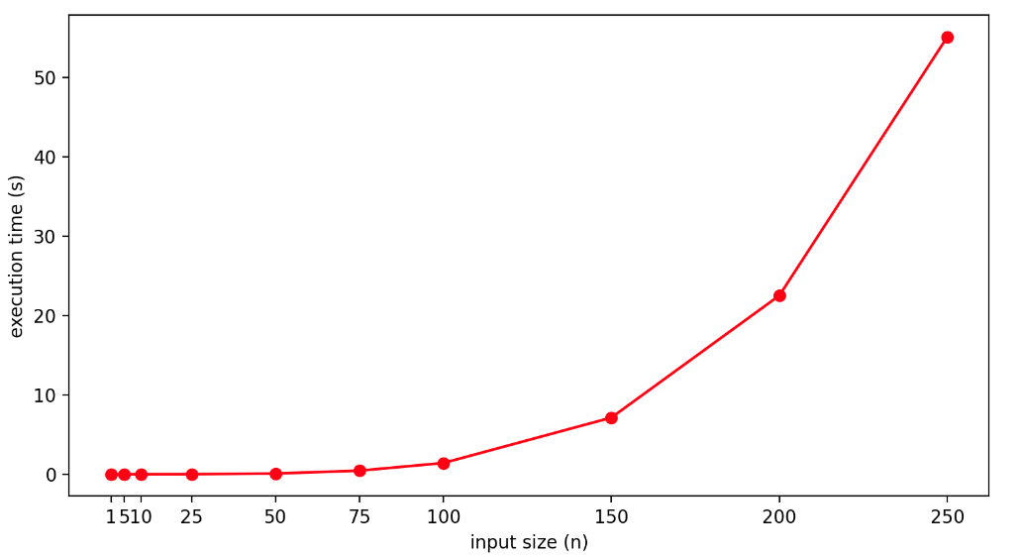

#### Graph of the theoretical analysis when basic operation is the operation marked as (1)

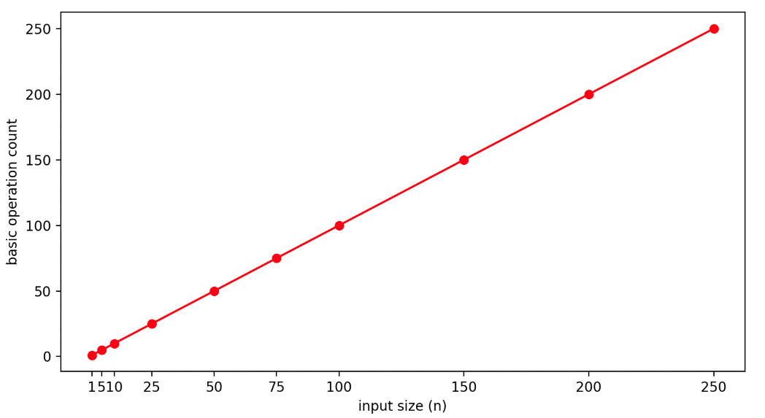

#### Graph of the theoretical analysis when basic operation is the operation marked as (2)

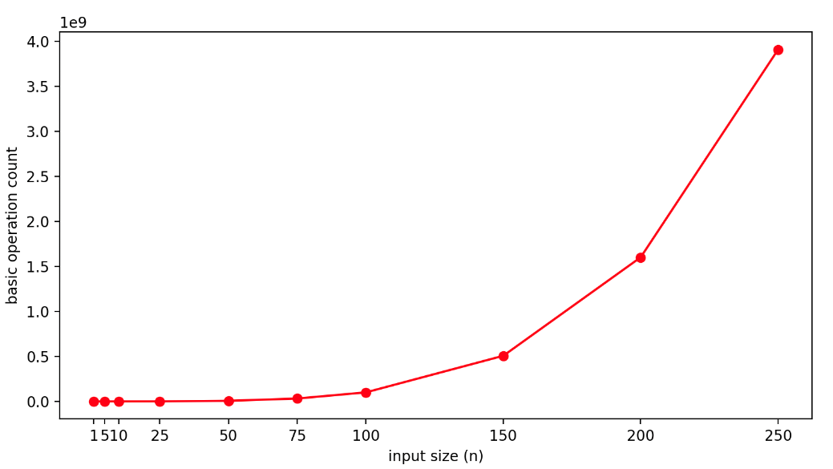

#### Graph of the theoretical analysis when basic operation is the operation marked as (3)

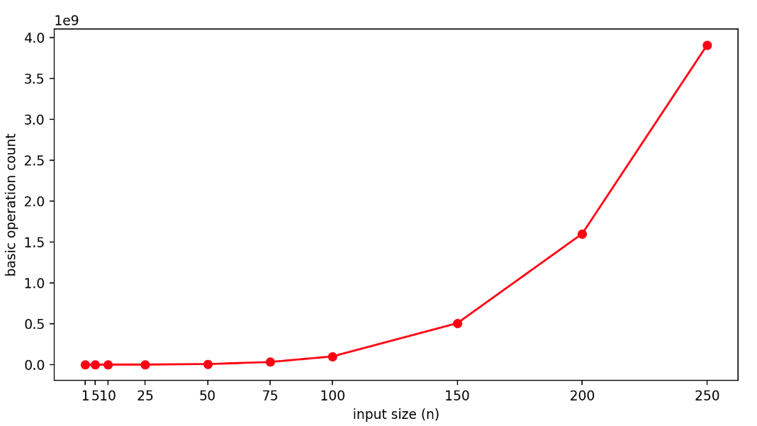

#### Graph of the theoretical analysis when basic operation is the operation marked as (4)

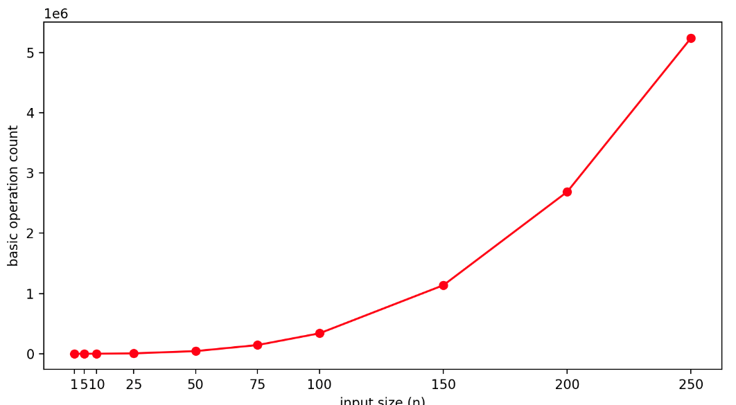

#### Graph of the theoretical analysis when basic operation is the operation marked as (5)

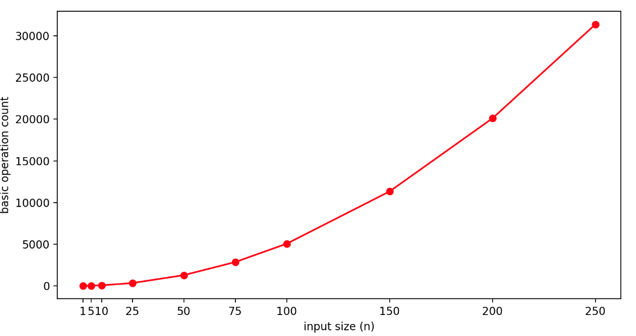

#### Comments

For the worst cases, the graph of basic operation (1) is linear whereas (2), (3) are the same and quartic, (4) is cubic and (5) is quadratic. The shapes look similar, however when the ratios of the execution time and basic operation count are considered, the algorithm seems to have a growth rate most similar to (2) and (3) which is $n^{4}$.

### Average Case

#### Graph of the real execution time of the algorithm

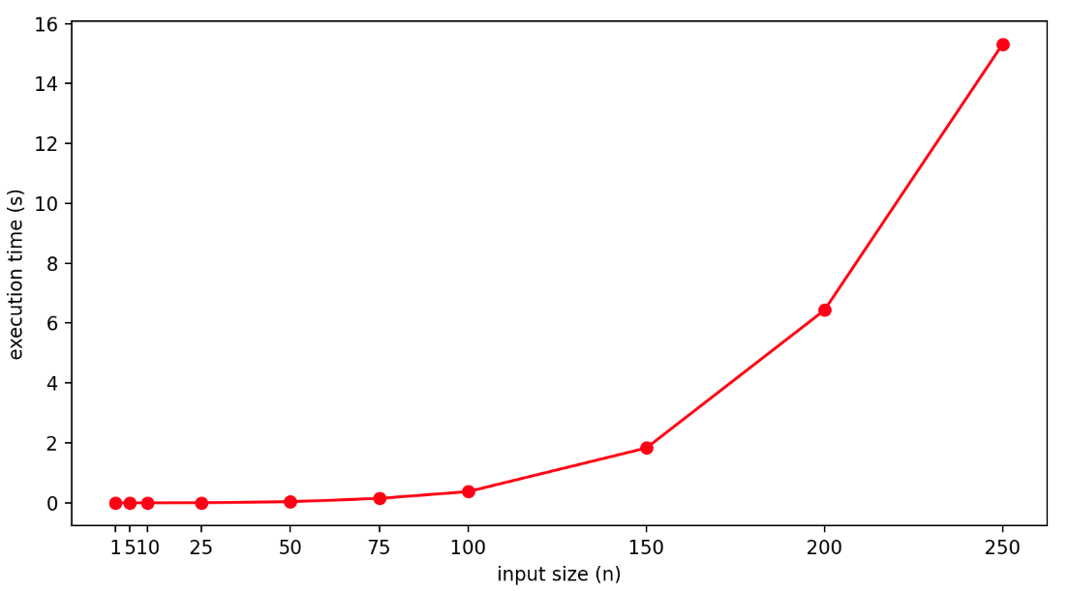

#### Graph of the theoretical analysis when basic operation is the operation marked as (1)

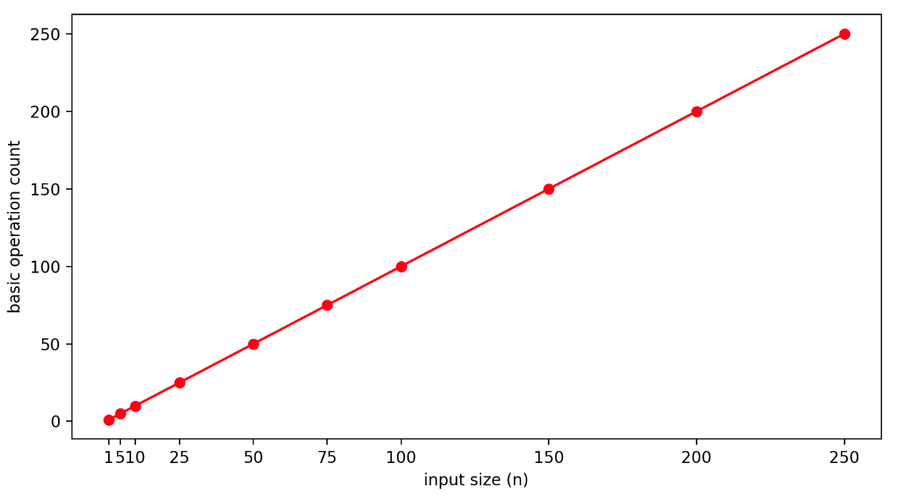

#### Graph of the theoretical analysis when basic operation is the operation marked as (2)

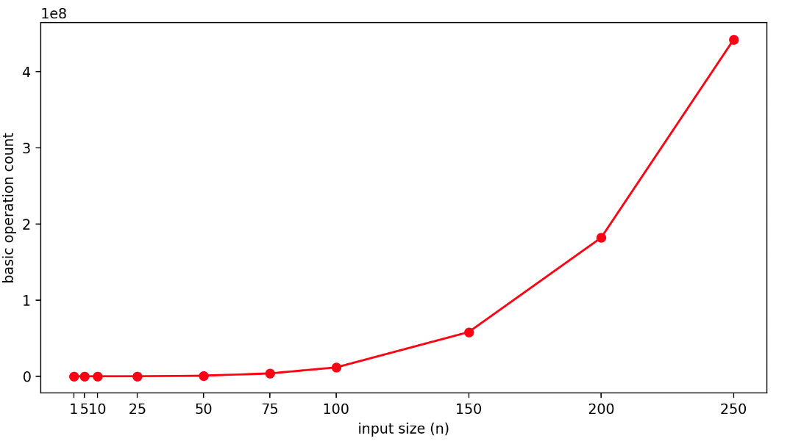

#### Graph of the theoretical analysis when basic operation is the operation marked as (3)

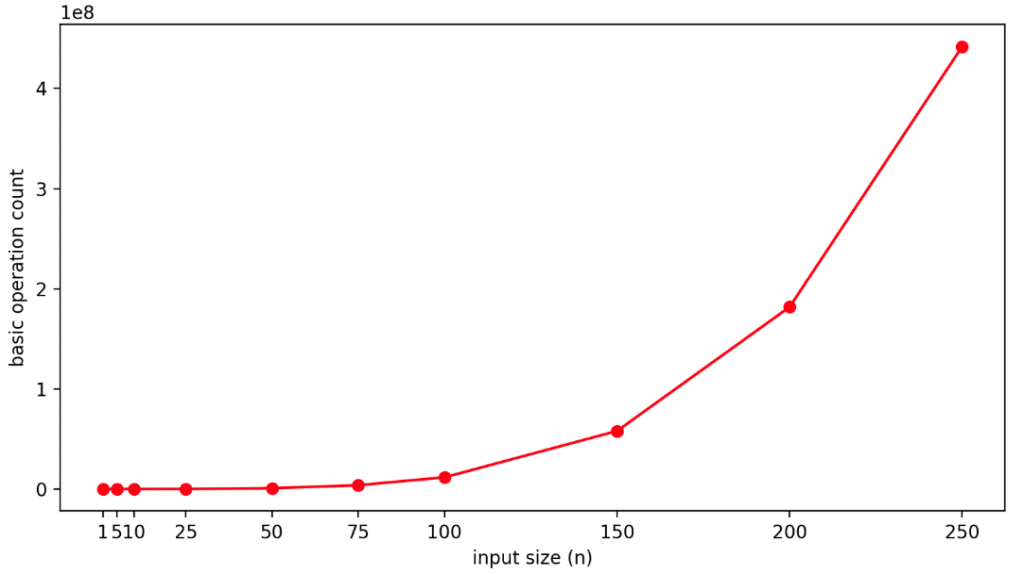

#### Graph of the theoretical analysis when basic operation is the operation marked as (4)

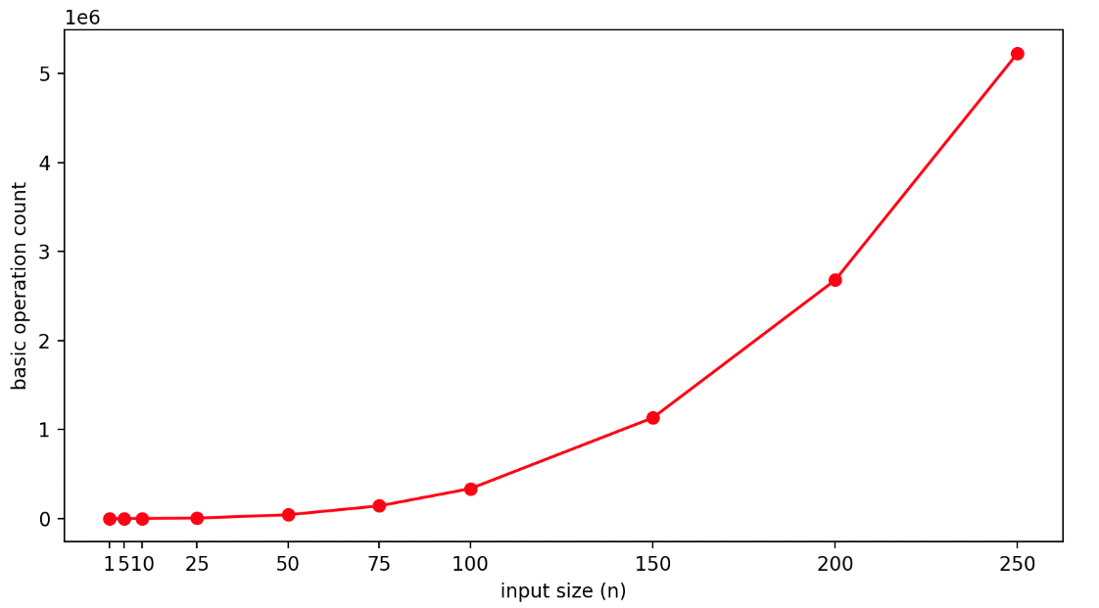

#### Graph of the theoretical analysis when basic operation is the operation marked as (5)

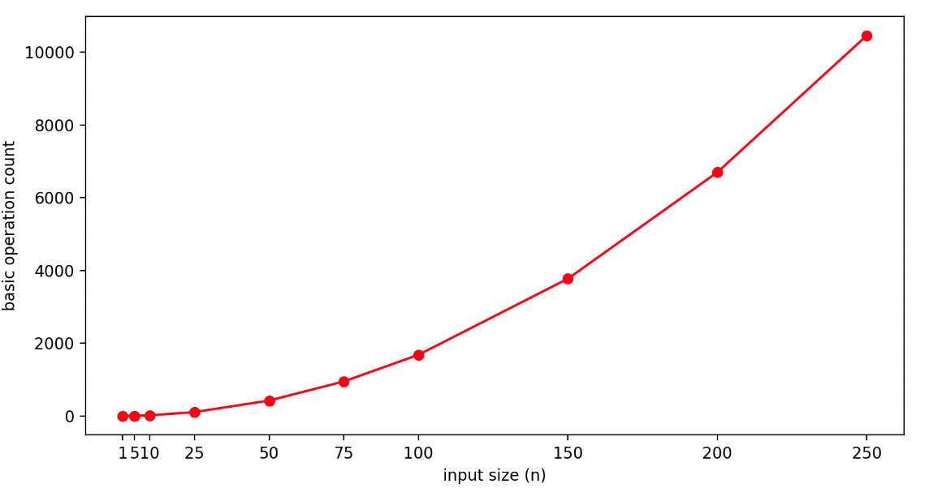

#### Comments